**Data Analysis**

* The human resource data was obtained from Kaggle website.
* The data was clean and did not require any cleaning.
* Used SQL to write queries which provide the needed data.
* Used power BI for visualization

----1. What is the size of each continent?

select Continent, sum(Area_km) as Total_Area from [World Population]

group by Continent

order by Total_Area Desc

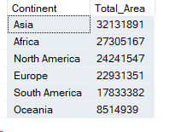

----2. What is the 2023 population of each continent?

select Continent, sum(Yr_2023) as Total_Population from [World Population]

group by Continent

order by Total_Population Desc

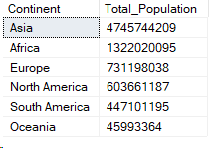

----3. What is the 2023 global population?

select sum(Yr_2023) as '2023 Global Population' from [World Population]



----4. Total population per census period

select Continent, sum(Yr_1950) as Population_1950, sum(Yr_1960) as Population_1960, sum(Yr_1970) as Population_1970,

sum(Yr_1980) as Population_1980, sum(Yr_1990) as Population_1990, sum(Yr_2000) as Population_2000,

sum(Yr_2010) as Population_2010, sum(Yr_2020) as Population_2020, sum(Yr_2023) as Population_2023 from [World Population]

group by Continent

order by Population_1950 Desc

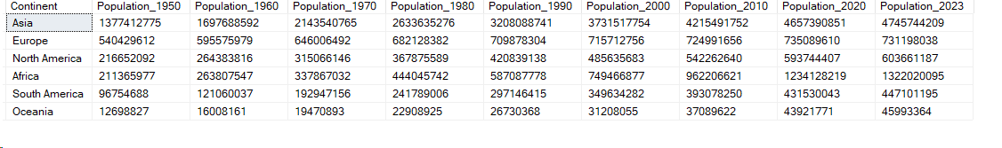

----5. 2023 top 10 populous countries

select top 10 country, sum(Yr_2023) as Population_2023 from [World Population]

group by country

order by Population_2023 desc

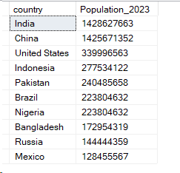

--6. 2023 top 10 populous cities

select top 10 Capital, sum(Yr_2023) as Population_2023 from [World Population]

group by Capital

order by Population_2023 desc

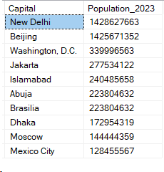

--7. Largest continent

select top 1 Continent as Largest_Continent_By_Size

FROM ( SELECT Continent, SUM(Area_km) AS Total_Area from [World Population] group by Continent) as Largest

order by largest.Total_Area desc ;

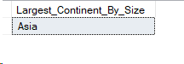

--8. Largest city by size

select top 1 Capital as Largest_City_By_Size

FROM ( SELECT Capital, SUM(Area_km) AS Total_Area from [World Population] group by Capital) as Largest

order by largest.Total_Area desc ;



--9. Largest city by population

select top 1 Capital as Largest_City_By_Population

FROM ( SELECT Capital, SUM(Yr_2023) AS Total_Population from [World Population] group by Capital) as Largest

order by largest.Total_Population desc ;



--10. Smallest continent

select top 1 Continent as Smallest_Continent_By_Size

FROM ( SELECT Continent, SUM(Area_km) AS Total_Area from [World Population] group by Continent) as Largest

order by largest.Total_Area asc ;



--11. Smallest city by size

select top 1 Capital as Smallest_City_By_Size

FROM ( SELECT Capital, SUM(Area_km) AS Total_Area from [World Population] group by Capital) as Largest

order by largest.Total_Area asc ;



--12. Small city by population

select top 1 Capital as Smallest_City_By_Population

FROM ( SELECT Capital, SUM(Yr_2023) AS Total_Population from [World Population] group by Capital) as Largest

order by largest.Total_Population asc ;

